**Governor Stirling Senior High School**

**Year 11 Physics**

**Task 4: Test 2 – Heating and Cooling**

**ANSWER ALL QUESTIONS IN THE SPACES PROVIDED**

**Name _______________________________________________**

Multiple choice: /15

Short answer /30

**Formulae and Selected Constants**

**Specific heat of ice = 2.10 x 103 J kg-1 K-1**

**Specific heat of steam = 2.00 x 103 J kg-1 K-1**

**Specific heat of water = 4.200 x 103 J kg-1 K-1**

**Specific heat of stainless steel = 445 J kg-1 K-1**

**Specific heat of aluminium = 900 J kg-1 K-1**

**Latent heat of fusion of water = 3.34 x 105 J kg-1**

**Latent heat of vaporisation of water = 2.25 x 106 J kg-1**

**Q = mc**∆**T**

**Q = mL**

**Electromagnetic Spectrum**

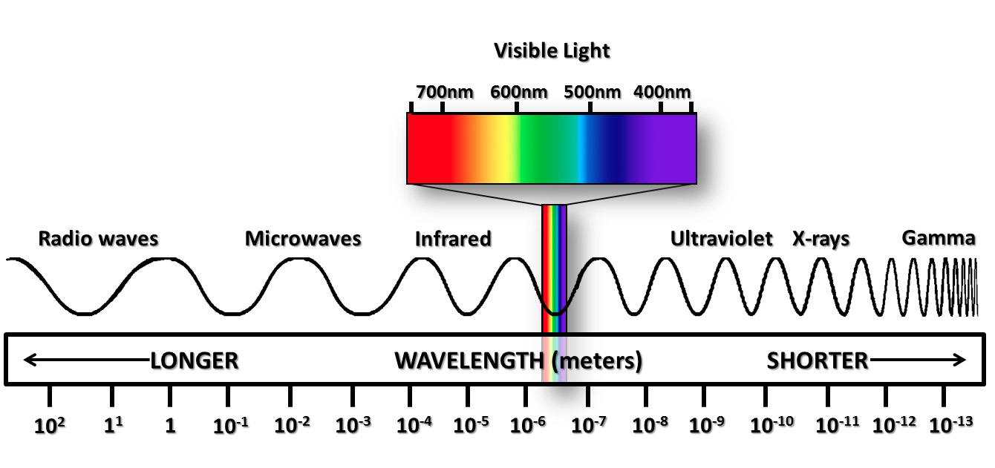

Section A consists of 15 questions, each worth one mark. Each question has only one correct answer. Circle the correct answer. Attempt all questions. Marks will not be deducted for incorrect answers.

1 What is the first law of thermodynamics?

A Matter can exist in four states: solid, liquid, gas and plasma.

B Matter can be neither created nor destroyed.

C Energy can be neither created nor destroyed.

D All matter is made up of small particles that are in constant motion.

2 How does the kinetic particle model define temperature?

A Temperature is the average rate of vibration of the particles.

B Temperature is the average speed of the particles.

C Temperature is the average velocity of the particles.

D Temperature is the average kinetic energy of the particles.

3 A (petrol) car sits at the bottom of a hill. A driver gets in and the car begins to accelerate up the hill. What is happening in terms of energy?

A As the petrol burns, heat energy is created.

B Chemical energy is converted into potential energy.

C Chemical energy is converted into kinetic energy.

D Chemical energy is converted into kinetic energy and potential energy.

4 A 100 g block of aluminium and a 100 g block of copper at room temperature are immersed in boiling water for 25 s. The specific heat capacity of aluminium is 900 J kg C–1 and of copper is 380 J kg C–1. Which will be at the highest temperature when they are both removed?

A The aluminium block

B The copper block

C Both will be at the same temperature.

D There is insufficient information to decide.

5 By which means is heat energy transferred?

A Convection

B Conduction

C Radiation

D All of the above

6 By which means is heat energy transferred through space?

A Convection

B Conduction

C Radiation

D All of the above

A solid substance is heated at a constant rate. The graph below shows how its temperature changes over time. Use this graph to answer the next 3 questions.

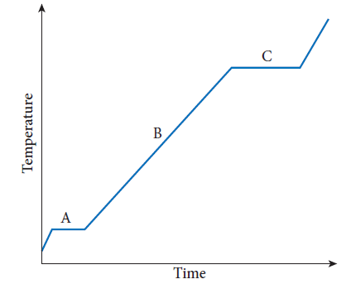

7 What is the state of the substance at point A on the graph?

A Solid

B A mixture of solid and liquid

C Liquid

D Part liquid and part gas

8 What is the state of the substance at point B on the graph?

A Solid

B A mixture of solid and liquid

C Liquid

D Part liquid and part gas

9 What is the state of the substance at point C on the graph?

A A mixture of solid and liquid

B Liquid

C Part liquid and part gas

D Gas

10 Which of the following would make a material a good conductor of heat?

A Delocalised electrons

B The presence of ions (charged atoms)

C The lack of delocalised electrons

D Lots of air holes

11 Which of the following is not a form of electromagnetic radiation?

A X-rays

B Gamma rays

C Cosmic rays

D Radiant heat

12 Which of the following is true of a closed system?

A Energy can enter or leave, but the amount of matter remains constant.

B Matter can enter or leave, but the amount of energy remains constant.

C Both the total amount of matter and the total amount of energy remains constant.

D No work from an external source is done on the system.

13 Which of the following would be an isolated system?

A The inside of a refrigerator with the door closed

B The inside of a thermos flask with the lid on

C Any planet or moon

D The human body

14 Joe Cool is considering the eaves, or roof overhang, in his new house, in relation to solar radiation. What do you advise him to do?

A To maximise the benefits of the sunshine, don’t have any eaves.

B Have short eaves to keep out the summer sun but let in the winter sunshine.

C Have long eaves to insulate the house, particularly from the hot summer sun.

D Eaves don’t matter – spend money on insulation instead.

15 A bar heater is the most useful form of heating in a large open space because:

A Convection is increased near the heater so more energy flows off to the people.

B Conduction is increased so more heat gets to the people quicker.

C Conduction, radiation and convection all get to the people quicker.

D Radiant energy goes directly to the people to heat them.

Section B Short answer (30 marks)

Section B consists of four questions. Write your answers in the spaces provided.

1 400 mL of an unknown liquid is heated by adding 4800 J of heat energy. This causes its temperature to rise from 14°C to 38°C. What is the specific heat capacity of the unknown liquid?

(3 Marks)

2 100 L of water at 10°C is added to a bath containing 500 L of water at 94°C. Find the final temperature of the bath, after it has reached thermal equilibrium, assuming no further heat is lost from the water. 1 L of water has a mass of 1 kg.

(3 Marks)

3 A 2 kg block of ice at 0°C is being heated at a steady rate of 240 J s–1. How long will it take to melt, given that the latent heat of fusion (melting) of ice is 334 kJ kg–1?

(3 Marks)

4 How much energy is required to convert a 1 kg block of ice at –10°C to water at 30°C? The specific heat capacities of water and ice are 4200 J kg–1 K–1 and 2100 J kg–1 K–1 respectively, and the latent heat of fusion (melting) of ice is 334 kJ kg–1.

(3 Marks)

5 This is a list of some different types of radiation:

radio waves, X-rays, visible light, infrared light, gamma rays, ultraviolet light

Re-order the list so it goes from:

a lowest energy to highest energy**.**

(2 Marks)

b lowest wavelength to highest wavelength.

(1 Mark)

c lowest frequency to highest frequency.

(1 Mark)

6 Find the efficiency of an 800 W heater that emits 45 600 J of heat energy in a minute.

(2 Marks)

7 Explain why a person standing in a breeze is more likely to feel cold if their clothes are wet rather than dry.

(2 Marks)

8 House insulation bats have an "R" value. **R** is called the **thermal resistance** of the material. The higher the value of R, the better the insulation.

The amount of heat conducted through an insulator per square metre each second, **H**, and the temperature difference across it, **(Th - Tc)**, are related to the thermal resistance of the insulator by the following formula:

Th – Tc

R = -----------

H

where Th and Tc are the respective temperatures on the hot and cold sides of the insulator.

A ceiling insulator has an R value of 3.0

1. Calculate the amount of heat conducted through it per square metre each second when the temperature difference is 8.0 oC.

(2 Marks)

9 At a certain time, insolation is 160 J m2 s1, of which 10% is reflected. Four solar hot water panels on the roof each measure 2.5 m × 1.5 m. The system contains 1000 L of water, of specific heat capacity 4200 J kg1 K1. The mass of 1 L of water is 1 kg.

a How much energy is received by the panels in an hour, assuming no heat loss other than the 10% reflection?

(3 Marks)

b By how many degrees will the temperature of the water rise in the hour?

(2 Marks)